Assignment-5

Name: BOYA DRAVEEN KUMAR

Trainer Name:HARSHEE PITRODA

Batch Number: **09(G-15)**

Course Name:**Mechain learning with python**

Date:**06-Jun-2022**



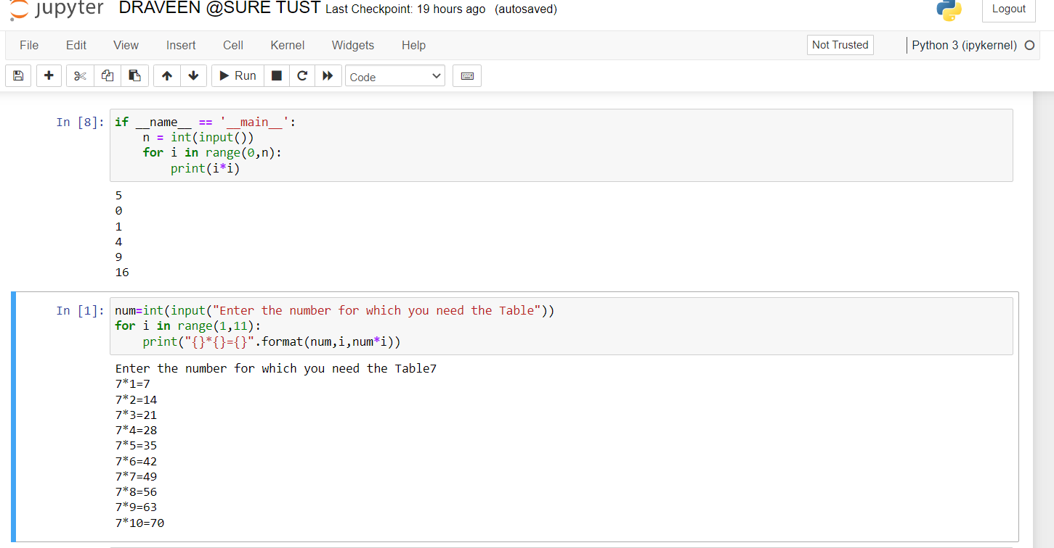

https://www.hackerrank.com/challenges/python-loops/problem

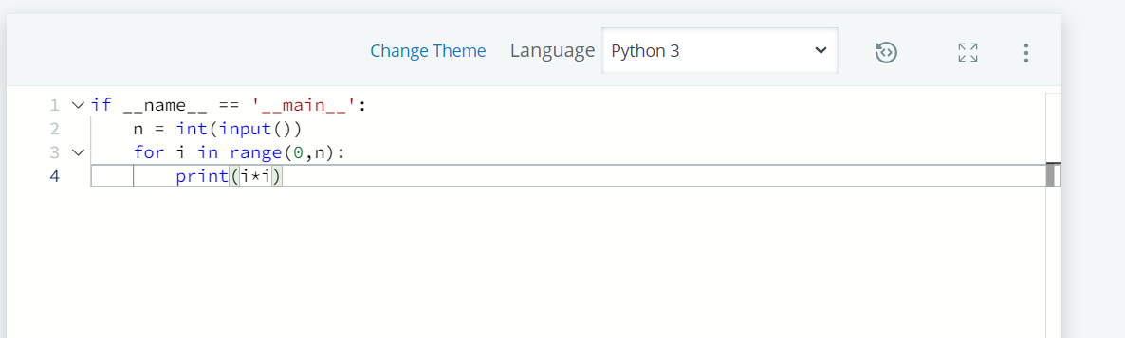

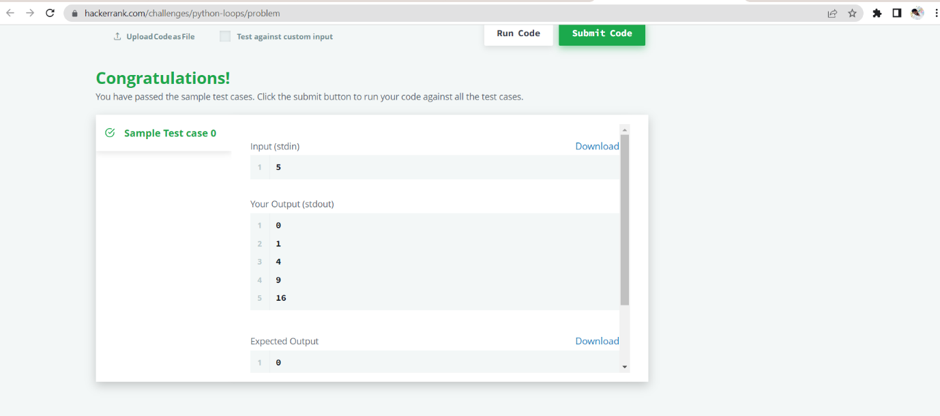

https://www.hackerrank.com/challenges/py-if-else/problem?isFullScreen=true

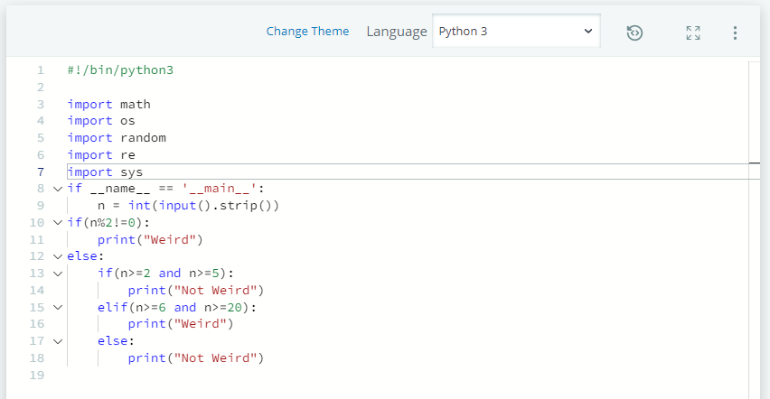

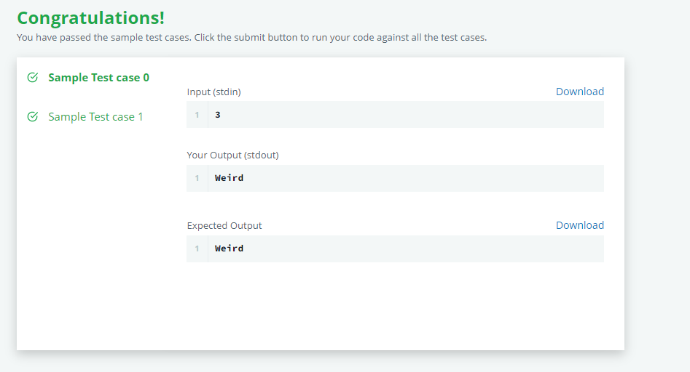

https://www.hackerrank.com/challenges/whats-your-name/problem?isFullScreen=true

